 | BELLINGHAM TECHNICAL COLLEGE  PARENTING EDUCATION
DEPT/COURSE #: CHFM 141 (non graded course)

COURSE TITLE: RAISING SCHOOL AGE CHILDREN

COURSE DESCRIPTION:
Being an effective parent is one of the most challenging tasks in life--as well as one of the most rewarding. This course will provide a practical approach to improving parent-child relations for parents of children ages 6-11 years. Participants will learn more effective ways to relate to their child, methods of discipline that develop responsibility in the child, how not to reinforce their child's unacceptable behaviors, and how to encourage cooperative behaviors.
COURSE OUTCOME:
To respond thoughtfully and more effectively to children, while maintaining respect for all people involved

COURSE OUTCOME ASSESSMENT:
Course outcome will be achieved by the successful completion of the projects listed under assignments/ requirements.
Course outcome will be achieved by successful mastery of all objectives listed below.

STUDENT PERFORMANCE OBJECTIVES (Course competencies):
Upon completion of the course, the parent or caregiver will be able to:
- Apply principles of Adlerian psychology (a values-based, fully integrated theory of personality) using the concept of mistaken goals.
- Apply skills for listening, resolving conflicts and exploring alternatives with children.
- Analyze personal values and teaching strategies surrounding sexual exploration, media influences, drug prevention, personal safety and bullying issues.
- Create a plan for self-care.
- Evaluate the effectiveness of adult responses to challenging children’s behaviors.

COURSE OUTLINE:
Parenting styles, mistaken goals of misbehavior, birth order, school aged child development, sexual development, temperament, praise vs. encouragement, communication, building responsibility, emotion coaching, punishment vs. discipline, follow through, consequences and problem solving, overindulgence, parent/teacher communication, media influences, bullying, sibling rivalry, multiple intelligences, drug prevention, and family meetings.

METHODS OF INSTRUCTION:
- Group activities, interaction, and discussion
- Handouts reading and review
- Lecture and discussion
- Audio-visual presentations
- Audio Podcasts
- Discussion Board Reflective Activities
- Readings
- Worksheets

COURSE MAP
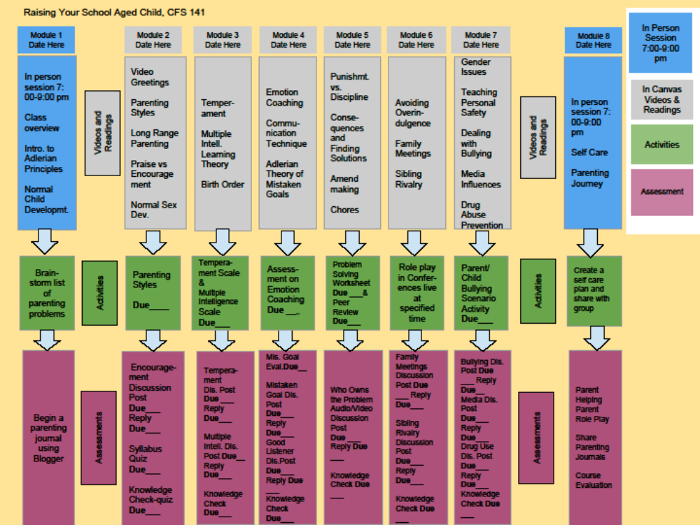

STUDENT ASSIGNMENTS/REQUIREMENTS:
- Read handouts, online readings and watch videos. Optional, read textbook.
- Complete online assignments

EVALUATION AND GRADING STANDARDS:
This is normally a non-graded course. To get the most out of your course, we suggest you
- Read class handouts and textbook.
- Complete online assignments.
- Practice parenting skills learned in class with your child(ren) outside of class.
- Review the BTC SharePoint site for Parenting Discussion courses.

If you choose to complete work for credits and a grade, the following are required:
- Inform the instructor during class that you want to register for a graded course and credit.
- Complete all online components of the course by the last in person session.

REQUIRED STUDENT SUPPLIES & MATERIALS:
Supplies: paper, pen, computer with online access and a webcam.
Optional: Text: Parents Handbook/Systematic Training for Effective Parenting, by Dinkmeyer and McKay, (rev. 2007)
ADDITIONAL INSTRUCTIONAL RESOURCES:
Program Share Point: http://www.btc.edu/pd

REQUIRED COMPUTER SKILLS
As you are enrolled in a course which has an online component, whether hybrid, online or web-enhanced, it is expected that you already have the basic skills needed to communicate with peers, access materials and submit your work. This includes web browsing, file management and document creation. If you don't feel confident in any of these areas, please let your instructor know.
NEW ONLINE LEARNERS
If you are new to online learning, BTC has various support options available to you to get you ready. In Learning to Learn Online you get the basics of studying in an online environment. In Canvas 101 you get the basics of Canvas, our Learning Management System (LMS).
REASONABLE ACCOMMODATION
If you are taking an online or hybrid course, sometimes technical difficulties can get in the way of accessing resources or submitting assignments. If you are unable to meet deadlines due to a technical or personal issue, before your work is due, please contact your instructor to talk about your options.
TECHNICAL SUPPORT
If you encounter content that doesn't display properly, or run into problems participating or submitting work, please contact your instructor. If you need help using Canvas, you can click the 'Help' link at the top-right of this screen.
ACCESSIBILITY
If you have difficulty reading, hearing or seeing content, or any other difficulties that might negatively impact your potential to succeed in this course, you may be eligible to receive help from our Accessibility Resources office. Call 360-752-8450, email ar@btc.ctc.edu or if you are on campus, stop by the AR office, located in the Counseling and Career Center, Room 106, College Services Building.

